TABLE 1 :
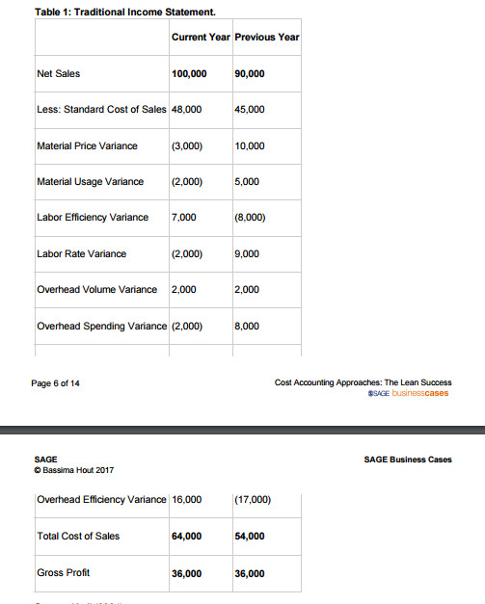

TABLE : 2

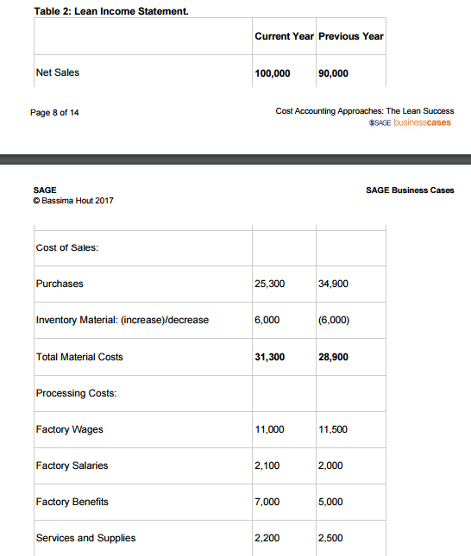

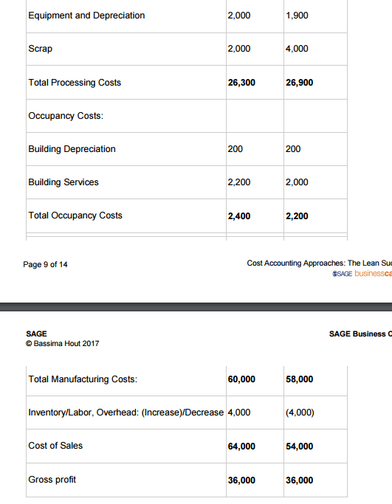

TABLE 3 :

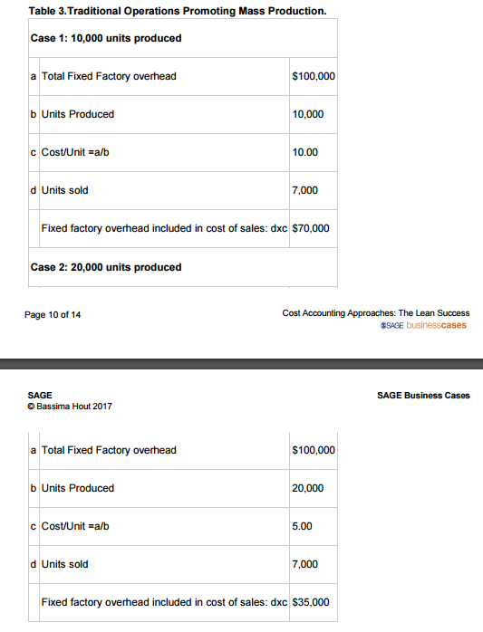

Financial statements analysis:

QUESTION 1 :
Traditional Income Statement (Table 1): The gross profit and gross profit percent are useful analysis tools for evaluating performance in a traditional cost accounting system. Use the traditional Income statement in Table 1 to determine the following.

- The difference in dollar amount of Gross Profit over the two years presented.

- Determine the Gross Profit % for each year.
 | Current Year | Previous Year
Gross Profit
Net Sales
GP %

- Based on Gross Profit % above, which year is more profitable?

- Based on your knowledge of traditional cost accounting system and related analytical tools :

1. Identify for each of the presented years, whether the variances used to adjust the standard Cost of Sales are favorable or unfavorable.

2. Provide a brief explanation of the noted change in variances above over the presented years.
 |  | Current Year Amount:  F/U* | Previous Year Amount: F/U | Explanation
1 | Material Price Variance | (3,000) F | 10,000 U
2 | Material Usage Variance
3 | Labour Efficiency Variance
4 | Labour Rate Variance
5 | Overhead Volume Variance
6 | Overhead Spending Variance
7 | Overhead Efficiency Variance

*F: Favourable variance, U: Unfavourable variance

QUESTION 2 Lean Income Statement (Table 2).
- Prepare a vertical analysis by calculating the percentage of each component of Cost of sales to Net Sales. (Round to the hundredth, two decimals).
 | Current Year | % | Previous Year | %
Net Sales | 100,000 |  | 90,000
Cost of Sales:
Purchases | 25,300 |  | 34,900
Inventory Material: (increase)/decrease | 6,000 |  | (6,000)
Total Material Costs | 31,300 |  | 28,900
Processing Costs:
Factory Wages | 11,000 |  | 11,500
Factory Salaries | 2,100 |  | 2,000
Factory Benefits | 7,000 |  | 5,000
Services and Supplies | 2,200 |  | 2,500
Equipment and Depreciation | 2,000 |  | 1,900
Scrap | 2,000 |  | 4,000
Total Processing Costs | 26,300 |  | 26,900
Occupancy Costs:
Building Depreciation | 200 |  | 200
Building Services | 2,200 |  | 2,000
Total Occupancy Costs | 2,400 |  | 2,200
Total Manufacturing Costs: | 60,000 |  | 58,000
Inventory/Labor, Overhead: (Increase)/Decrease | 4,000 |  | (4,000)
Cost of Sales | 64,000 |  | 54,000
Gross profit | 36,000 |  | 36,000

- Calculate the increase or decrease (as a percent of Net sales) for the following components below and comment on their changes.
 | Current Year % | Previous Year % | Increase/(Decrease) % | Explanation and interpretation of changes
Inventory Material: (increase)/decrease

Total Processing Costs

Total Occupancy Costs

Inventory/Labor, Overhead: (Increase)/Decrease

Cost of Sales

Gross profit

- In your opinion and based on your analysis above, which year demonstrates a better performance? (Max. 50 words)
QUESTION 3 :
Which income statement presentation provides a better basis for managerial performance assessment: Lean or Traditional? Justify in terms of profitability and operational efficiency (Waste reduction). (Max. 50 words)

